**Data Science Project (PhasE 1 COVER sHEET (Week 6))**

**Project Name:**

**Information *(typed not handwritten, except for the attendance signature)*:**

|  |  |  |
| --- | --- | --- |
| **ID** | **Full Name [In English]** | **Signature** |
| 320210022 | Ziad Tarek Mahmoud Fahmy |  |

**Project Idea (Define a clear problem):**

Collect data on LaLiga players includingteam name, position, Age,appearance or match played (subbed), Minutes played, Total goals, Total assists, Yellow card, Red card, Shots per game, Pass success percentage, AerialsWon- Aerial duels won per game, Man of the match. Knowing the best player of the tourmenet.Use data visualization techniques to create charts, graphs, and other visualizations to help stakeholders better understand the insights gained from the data.Preprocess the data to remove any errors, missing values, or outliers that could affect the analysis.This project could be valuable for clubs who are interested in identifying the most promising players and predicting future success

**Dataset Description**

This dataset provides detailed player statistics for the 2022-2023 La Liga season, including player names, team affiliations, goals, assists, appearances, yellow and red cards, shots per game, pass accuracy, and ratings. Uploading this data on Kaggle will allow users to easily analyze and compare player performance across the league, as well as develop models for predicting future outcomes. This dataset is a valuable resource for football analysts, sports enthusiasts, and anyone interested in the performance of La Liga players.  
**Columns**  
Name: NAme of a player  
TEam-Name: player's team name  
Age: Age  
Position: Playing position on the field  
App: appearance or match played (subbed)  
MinP: Minutes played  
Goals: Total goals  
Assists: Total assists  
YC: Yellow card  
RC: Red card  
SPG: Shots per game  
PS%: Pass success percentage  
AW : AerialsWon- Aerial duels won per game  
MOTM: Man of the match

**Define the goal(s)**

The dataset contains various attributes of players such as includingteam name, position, Age,appearance or match played (subbed), Minutes played, Total goals, Total assists, Yellow card, Red card, Shots per game, Pass success percentage, AerialsWon- Aerial duels won per game, Man of the match. The dataset can be used for various purposes such as analyzing player performance and making predictions about future performance. Additionally the dataset can be used by scouts, coachs and analysts to gain a deeper understanding of the its players.

**Define a solution:**

solution for a La Liga players dataset would involve organizing and analyzing data related to all the players in the Spanish football league. This could include information such as player names, positions, age, nationality, team affiliation, performance statistics (goals scored, assists, etc.), and other relevant data points.  
  
 The goal of this solution would be to provide valuable information for coaches, scouts, and fans to make informed decisions about player recruitment and team strategy.

**Show the Preprocessing Steps (Python):** dataset before and after.

- Plot of data with different plots (scatter, heat map,.....etc) and description.

- Data cleaning (Null, outlier,...etc.)

- Data scalling or normalizing

- Statistics of this data (mean, varience, covarience, correlation,.......etc.)

**- Dimensionality reduction using** Linear discriminant Analysis (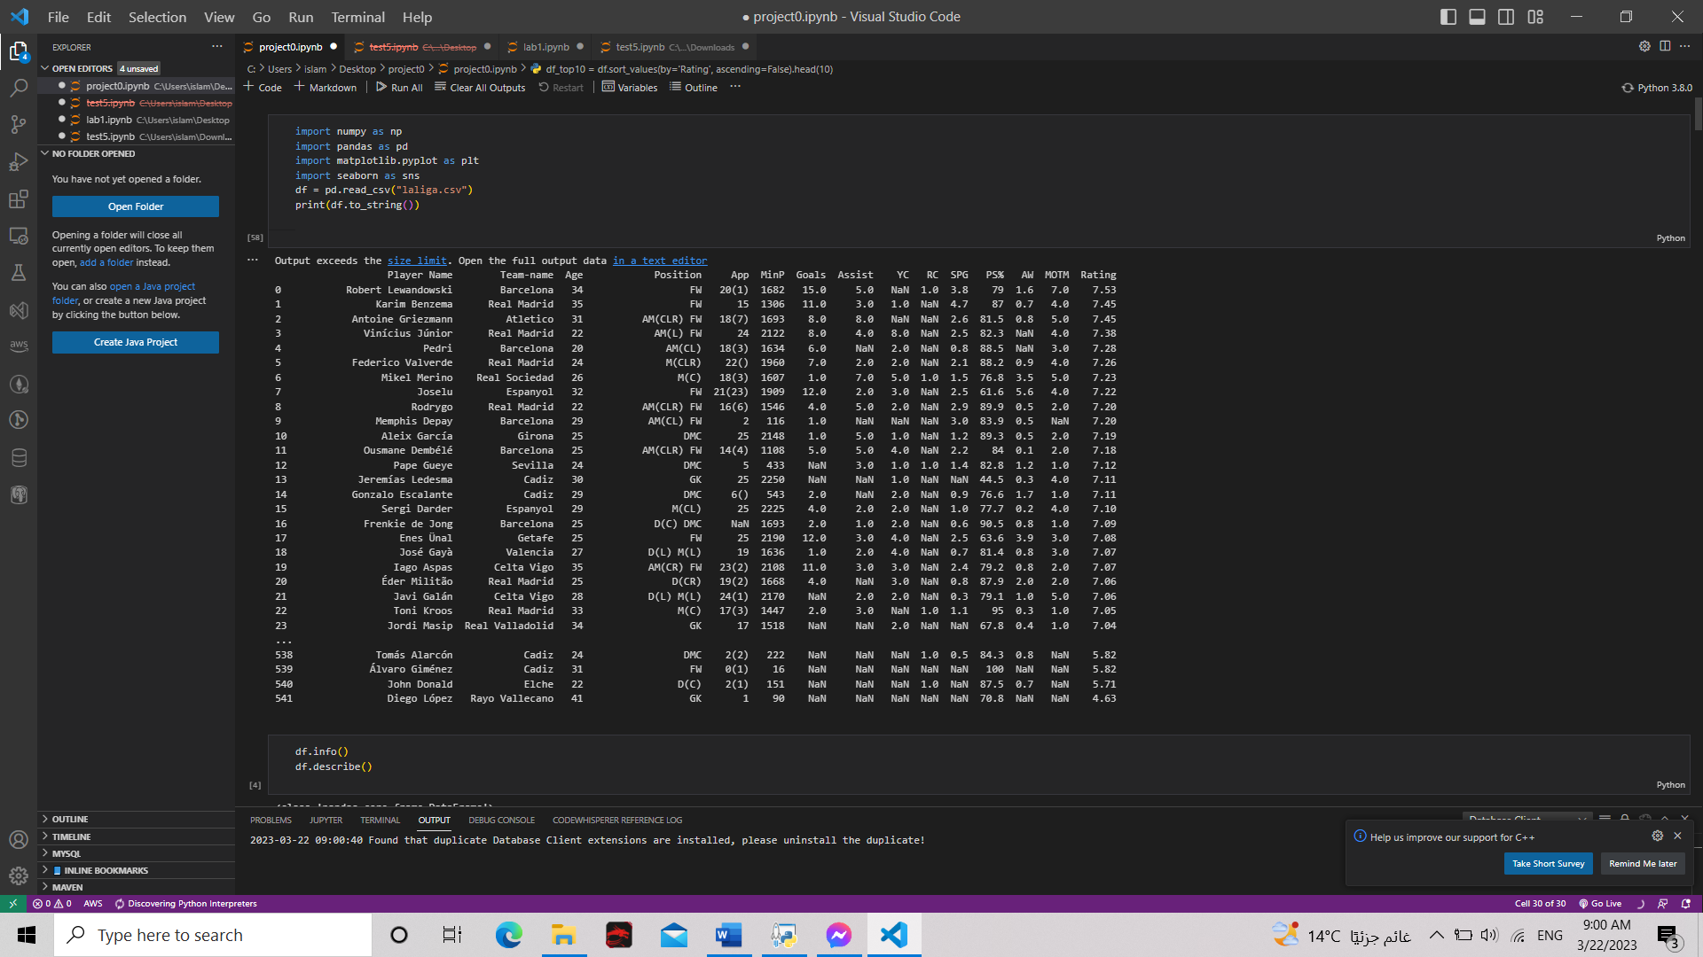LDA) 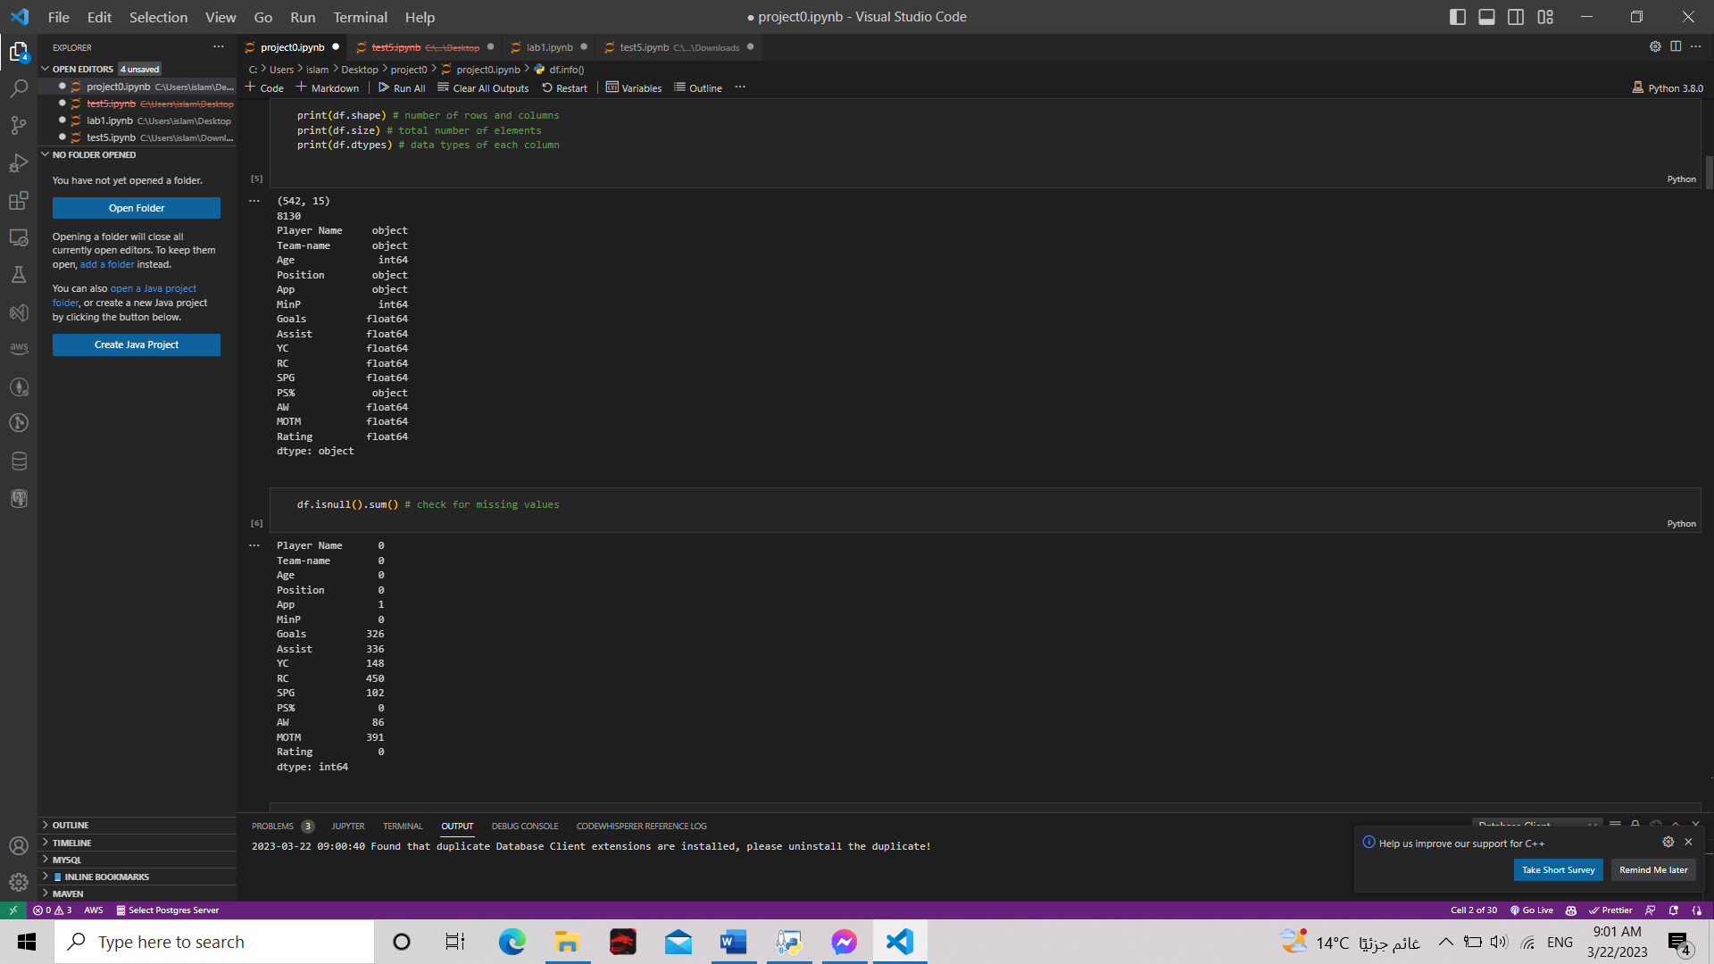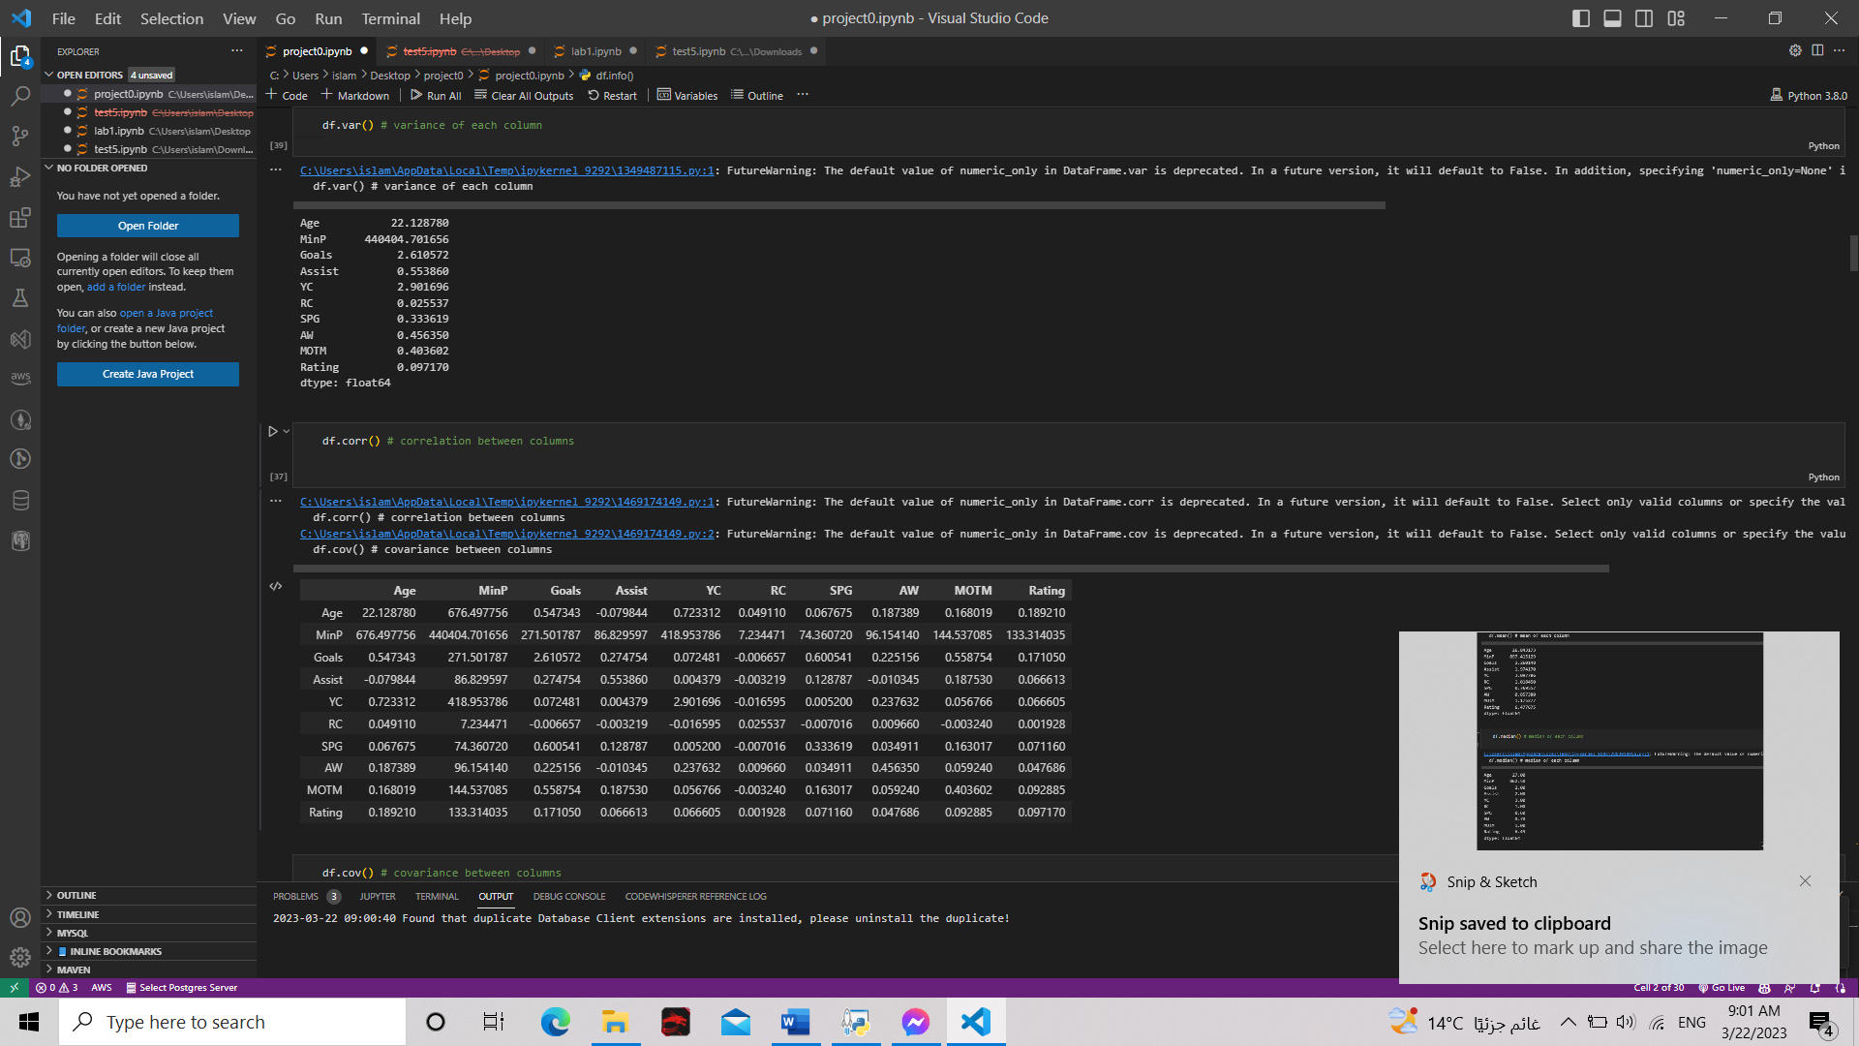

**17**

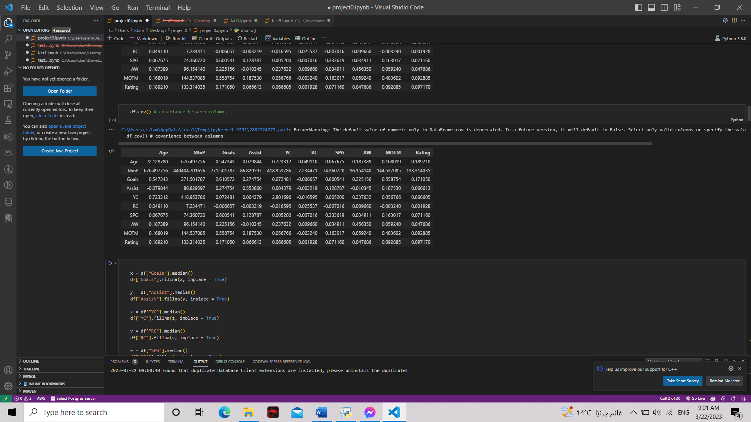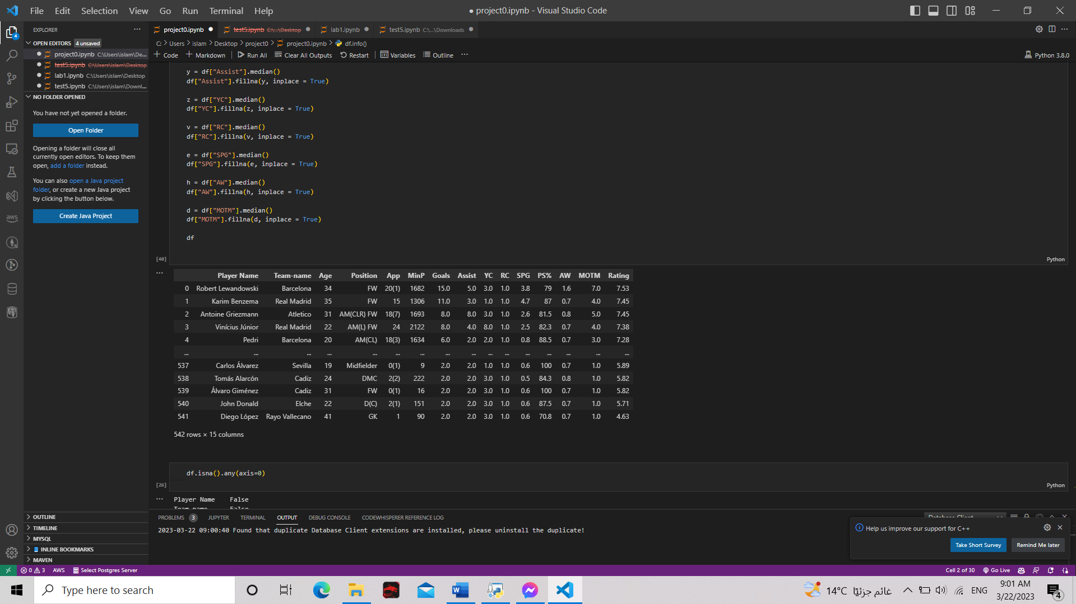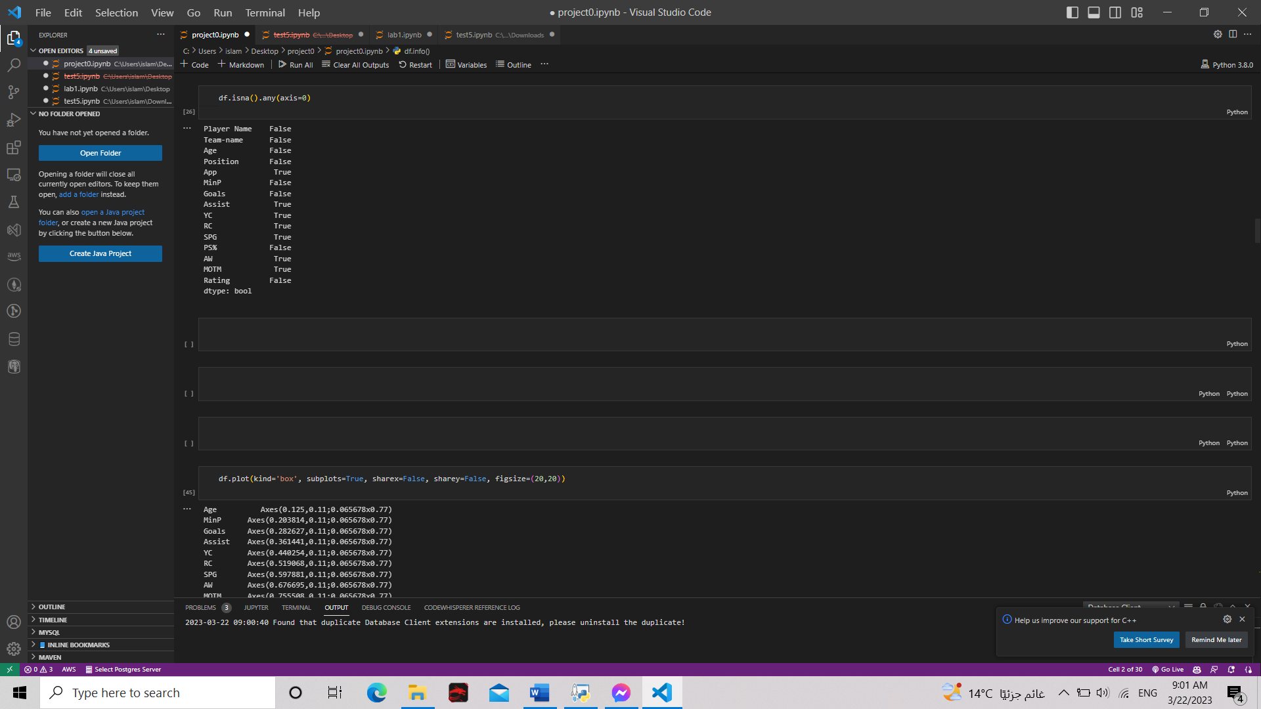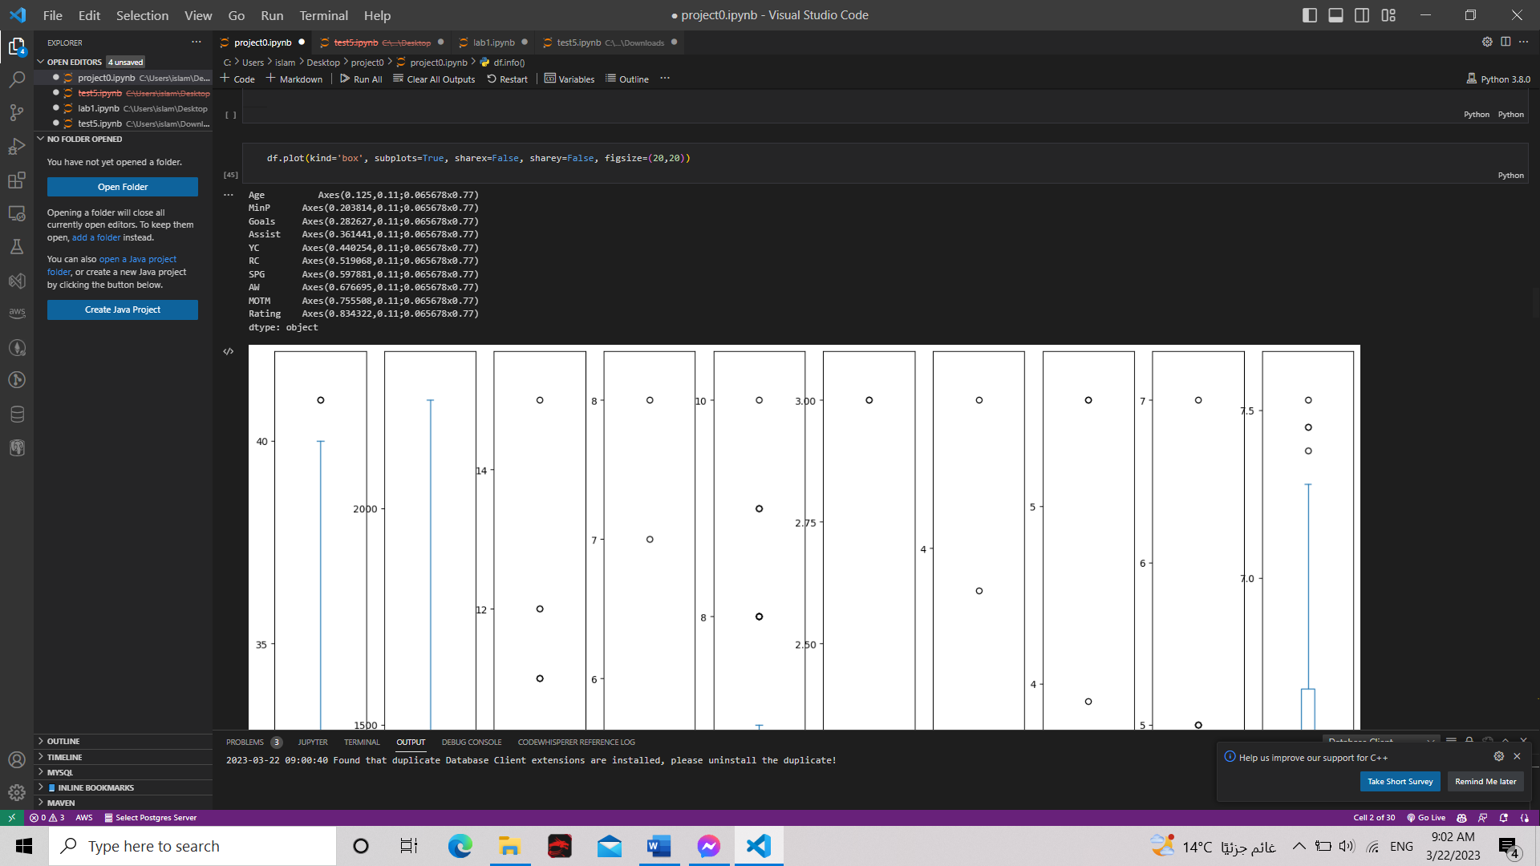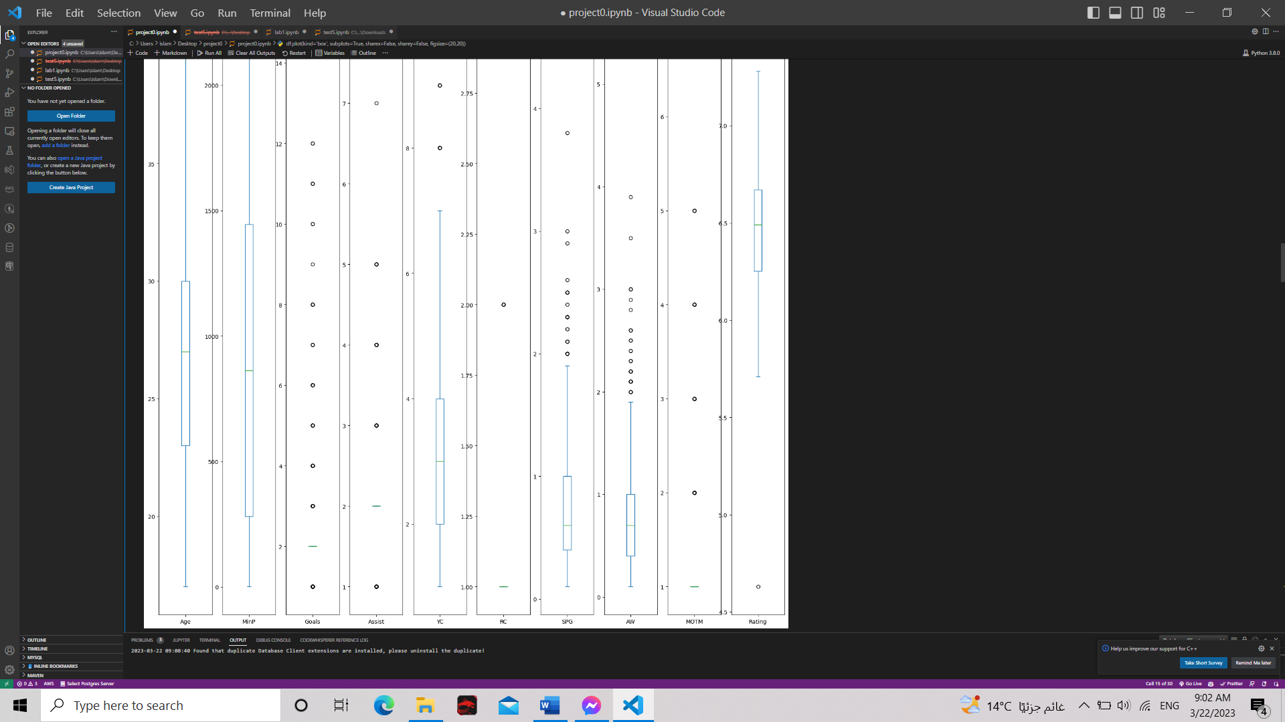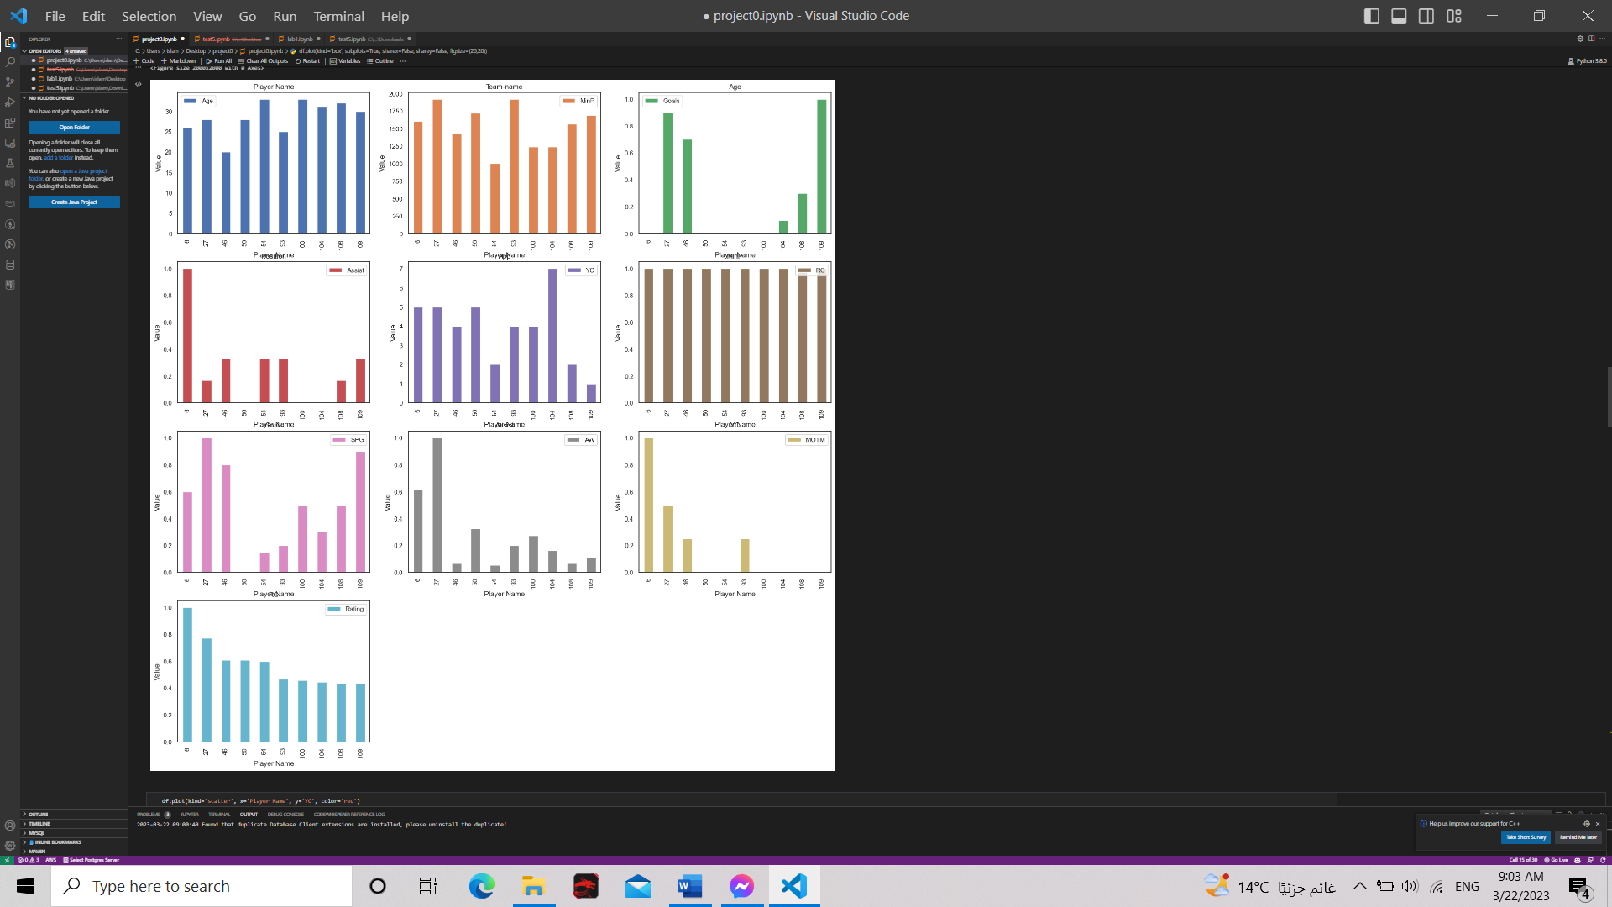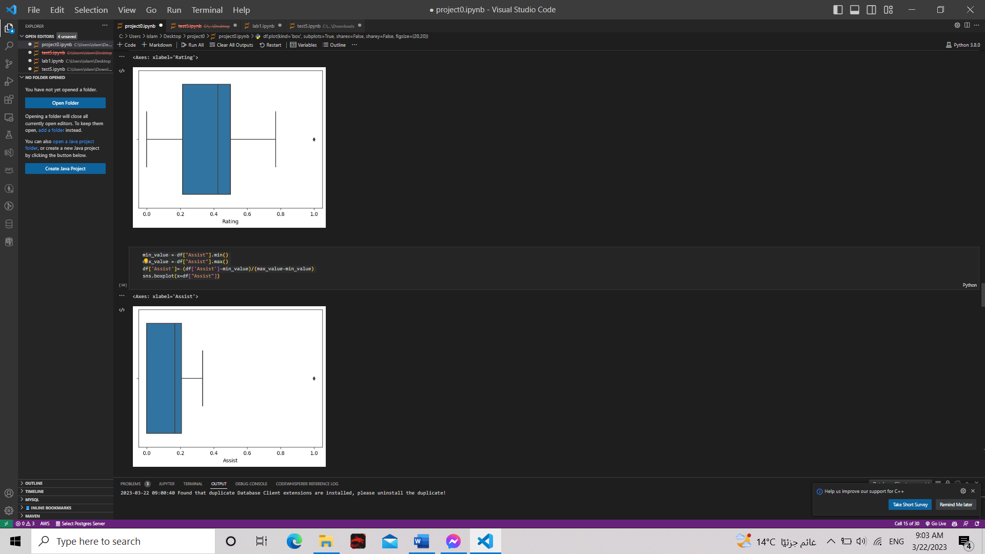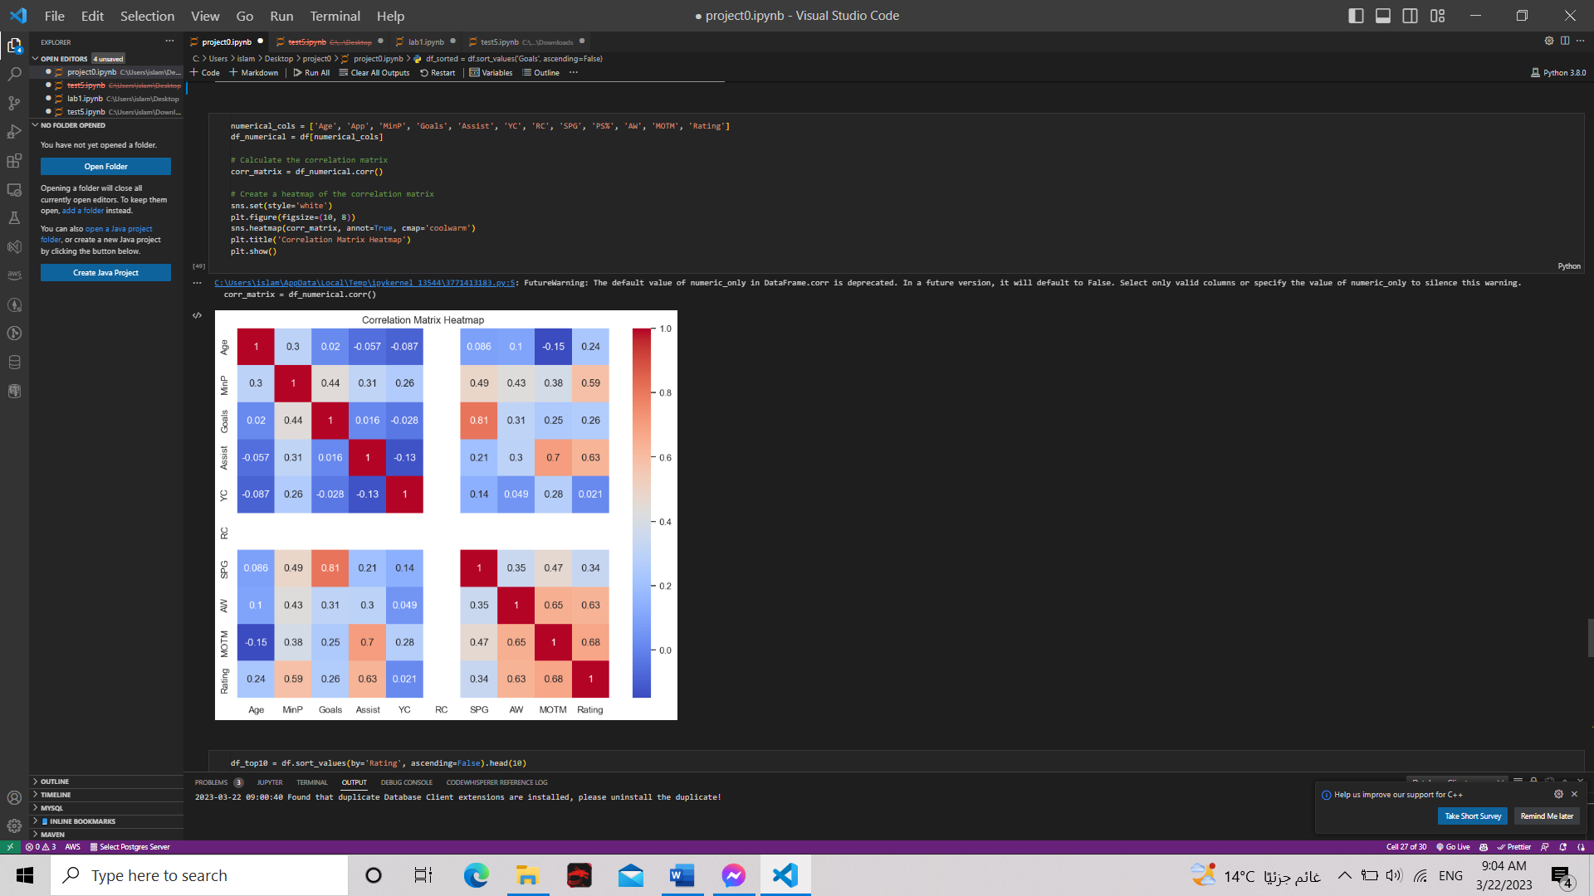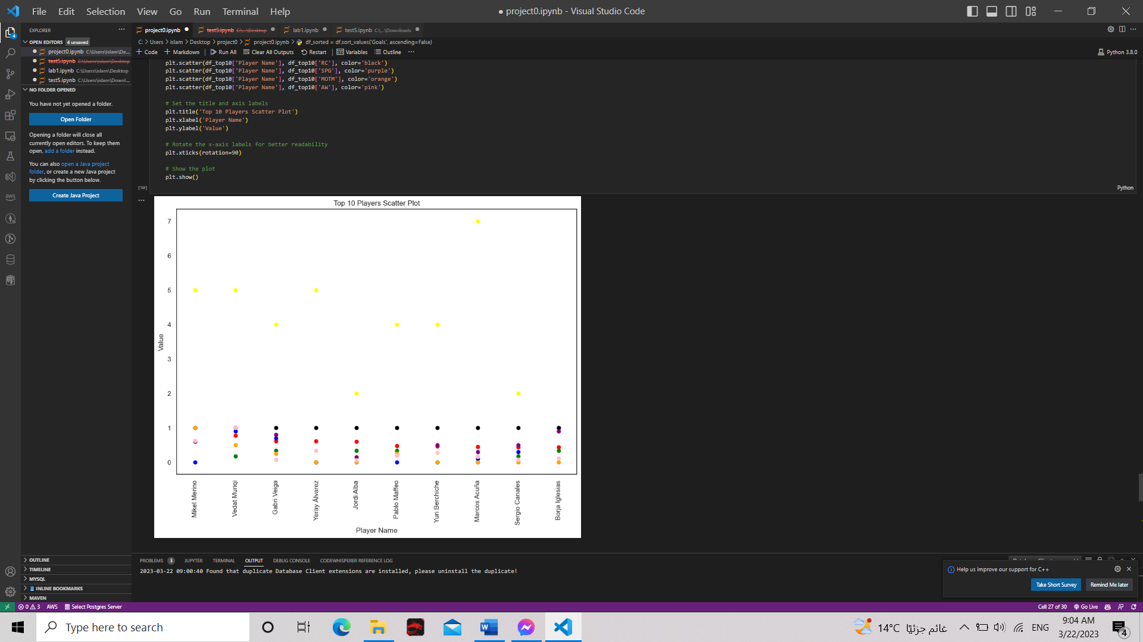

**Identify the Stakeholders:**

**6**

1. Fans: They are the ones who support and follow their favorite players, attend matches, buy merchandise, and generate revenue for the league.  
  
2. Clubs:They invest in players, pay their salaries, and rely on them to perform well on the field.  
  
3. Sponsors: They invest in the league and its players to promote their brand and increase visibility.  
  
4. Broadcasters: Broadcasters who air LaLiga matches are stakeholders as they rely on the league's popularity to attract viewership and generate advertising revenue.  
  
5. Agents: Agents who represent LaLiga players are also stakeholders as they negotiate contracts, endorsements, and other deals on behalf of their clients.  
  
6. National Teams: National teams that select LaLiga players for international competitions are also stakeholders as they rely on these players to represent their country at the highest level.  
  
8. Regulatory Bodies: Regulatory bodies such as FIFA and UEFA that oversee football globally are also stakeholders as they set rules and regulations that affect LaLiga players' careers and the league's operations.

**Teaching-Assistant’s Signature: _________**